**AUTOMATION TEST**

Step 1: Install JMETER for automation testing.

Step 2: The test plan will show in JMETER home page.

Step 3: Change the test plan as appropriate project name and save the project.

Step 4: Right click on test plan choose “Add” option, in “Add” option choose Thread(users),

in “Thread” choose “Thread group”.

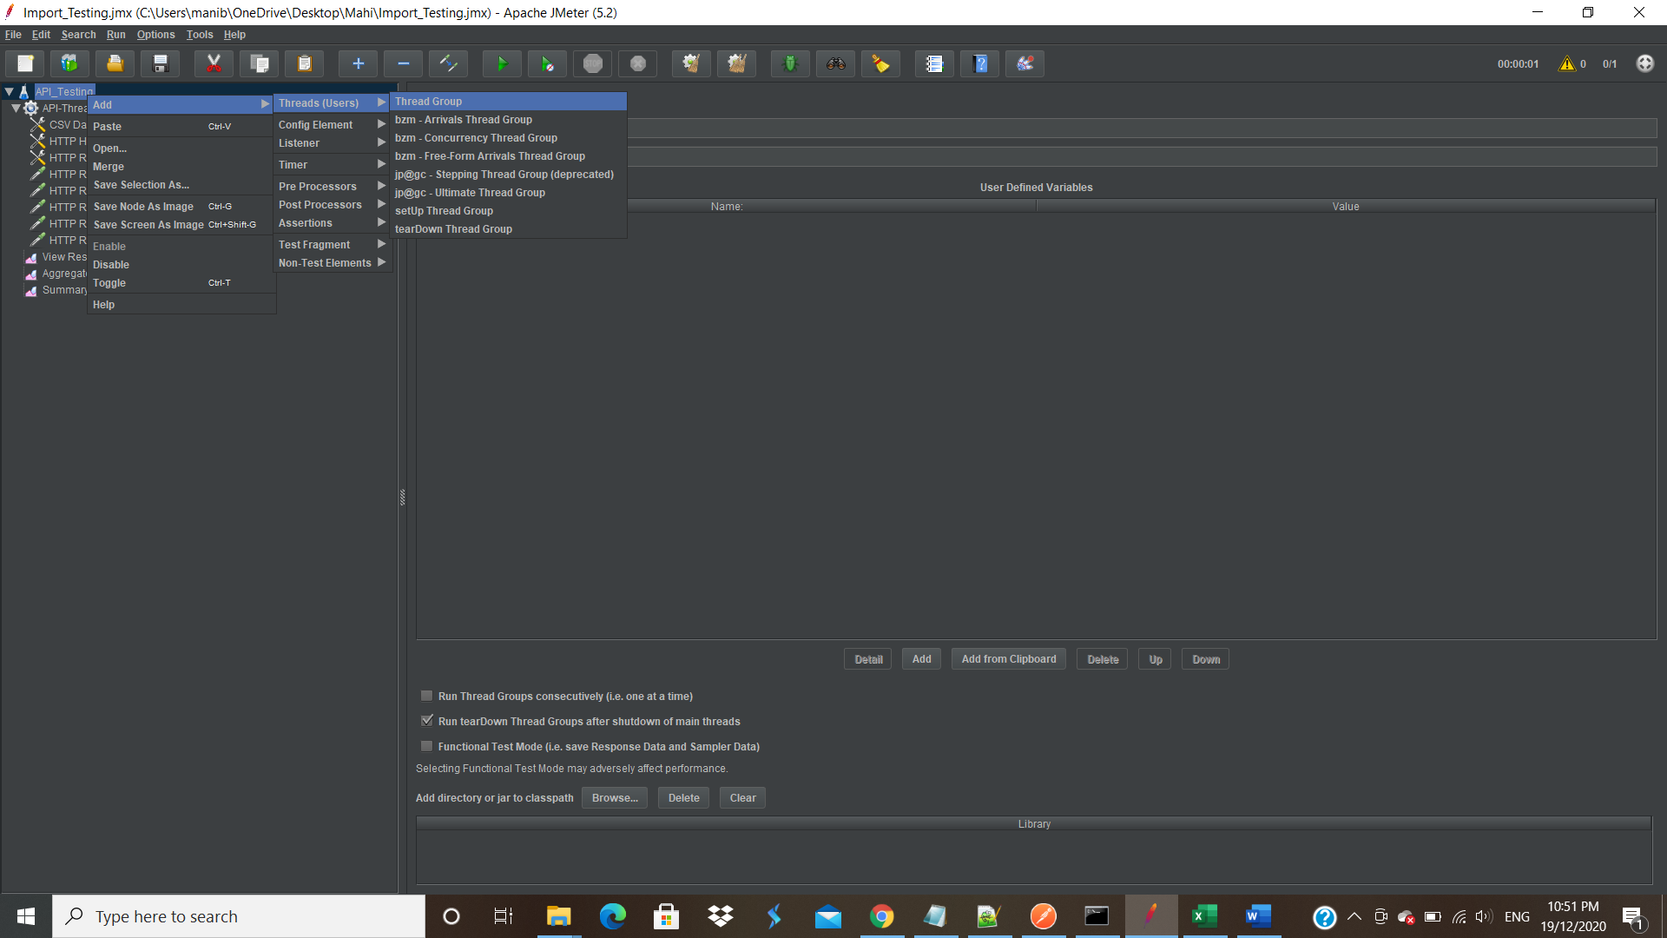

Step 5: Once thread group is created the below page is shown.

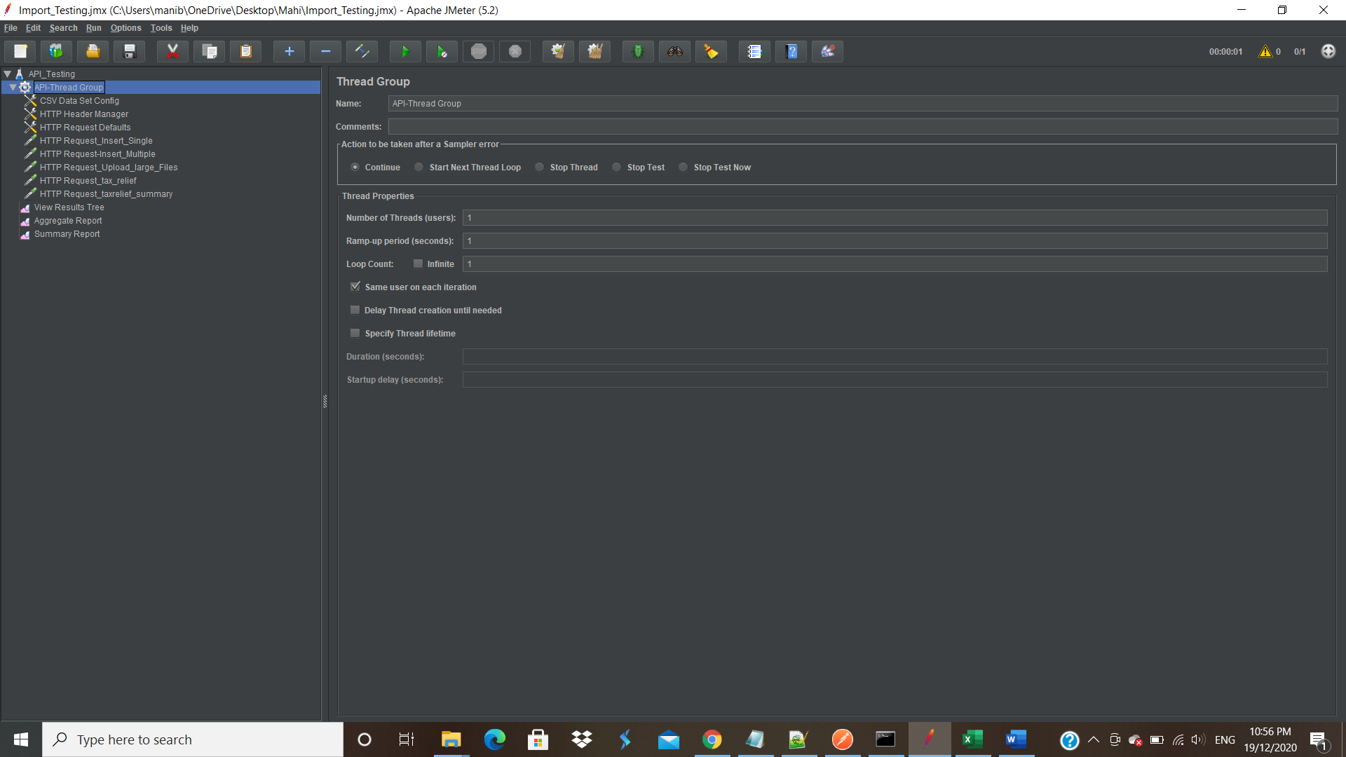

Step 6: Create HTTP Header Manager, to set the content type.

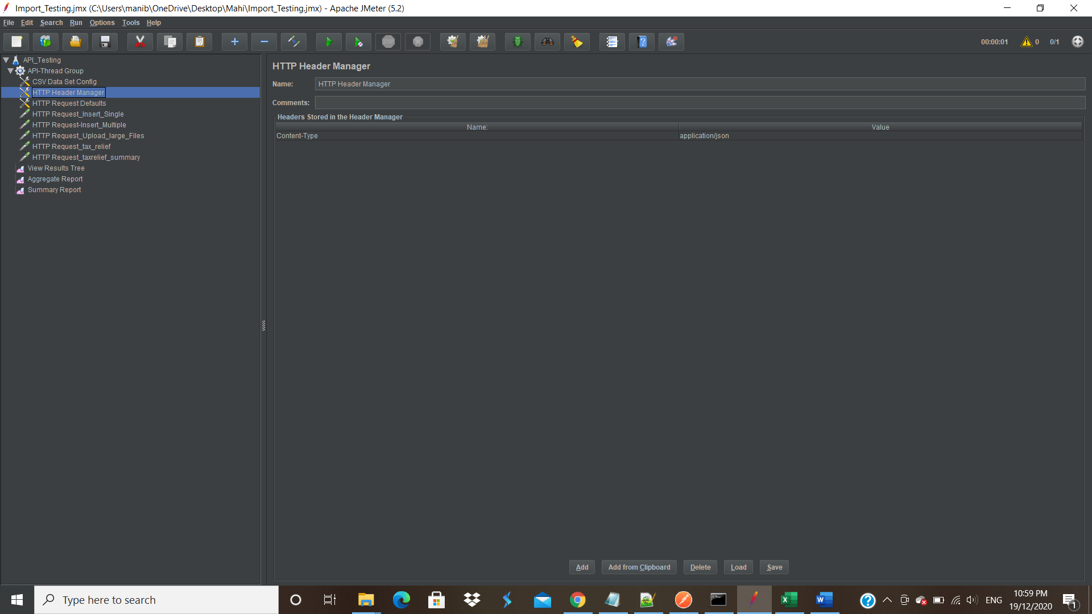

Step 7: Create HTTP Request Defaults, to set the Protocol, Server Name/IP and Port Number.

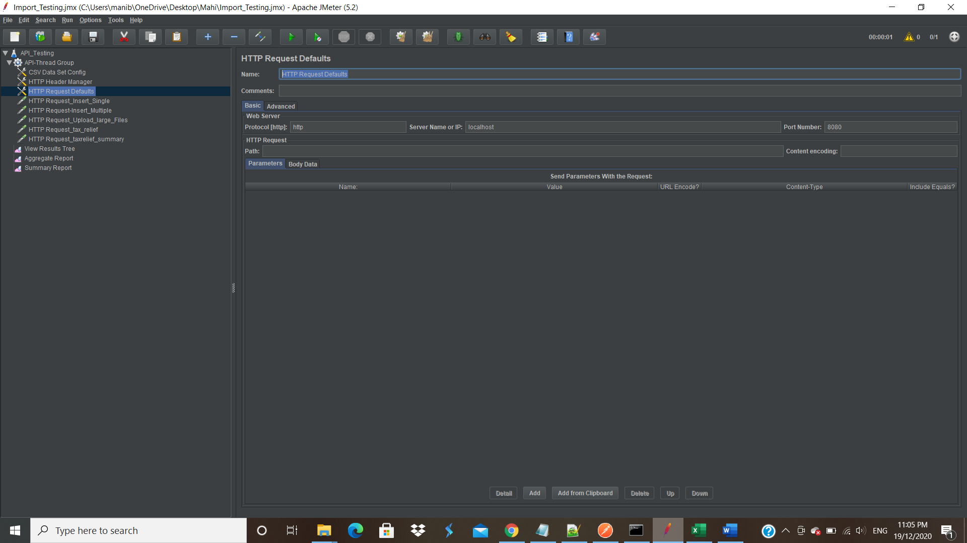

Step 8: Right click on” Thread Group”, click “Add” option, in “Add” select “Sampler, in

“Sampler” select “Http Request”.

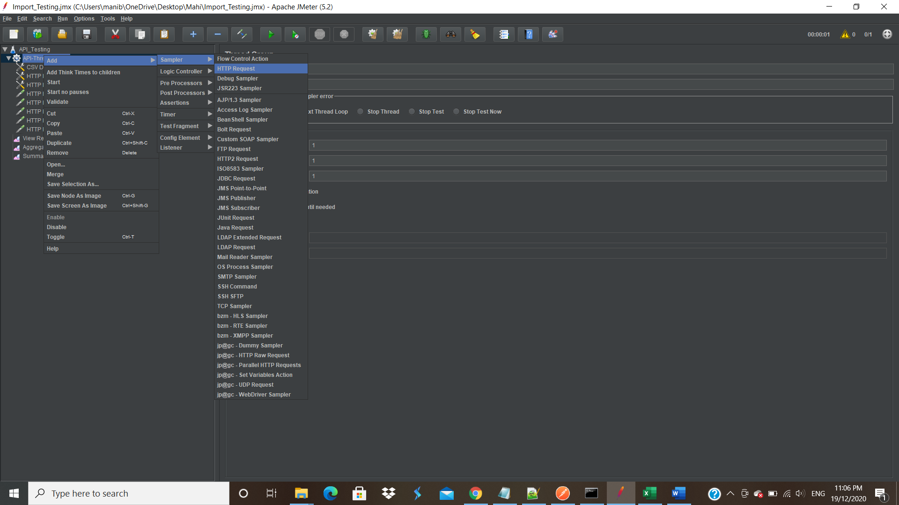

Step 9: For “Single Insert”,

1. In web Server, Set Protocol, Server Name/IP and Port Number.
2. In HTTP Request, Set Method as POST and Path.
3. In Body Data, provide json Request for single data insert.

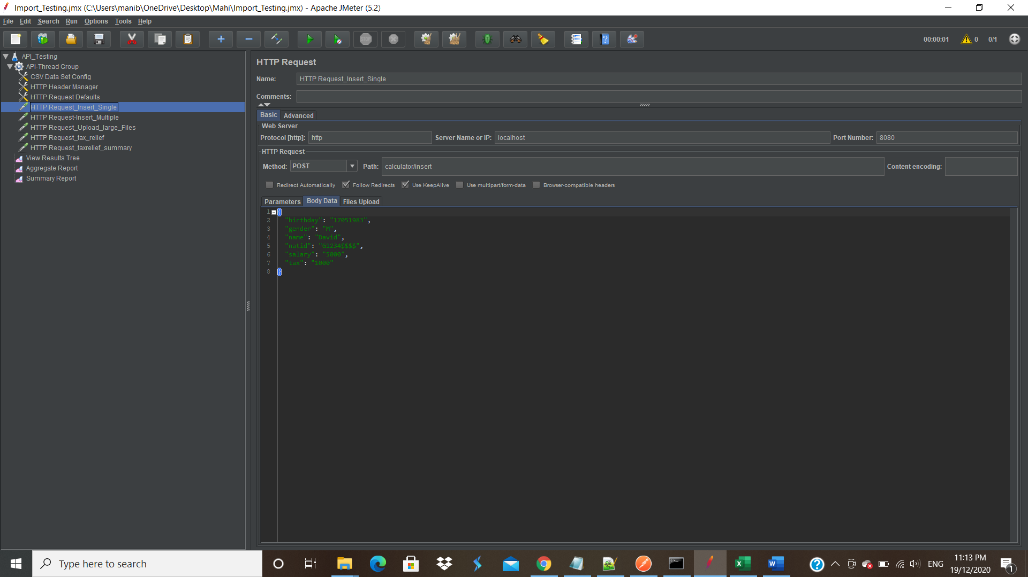

Step 10: For “Multiple Insert”,

1. In web Server, Set Protocol, Server Name/IP and Port Number.
2. In HTTP Request, Set Method as POST and Path.
3. In Body Data, provide json Request for multiple data insert.

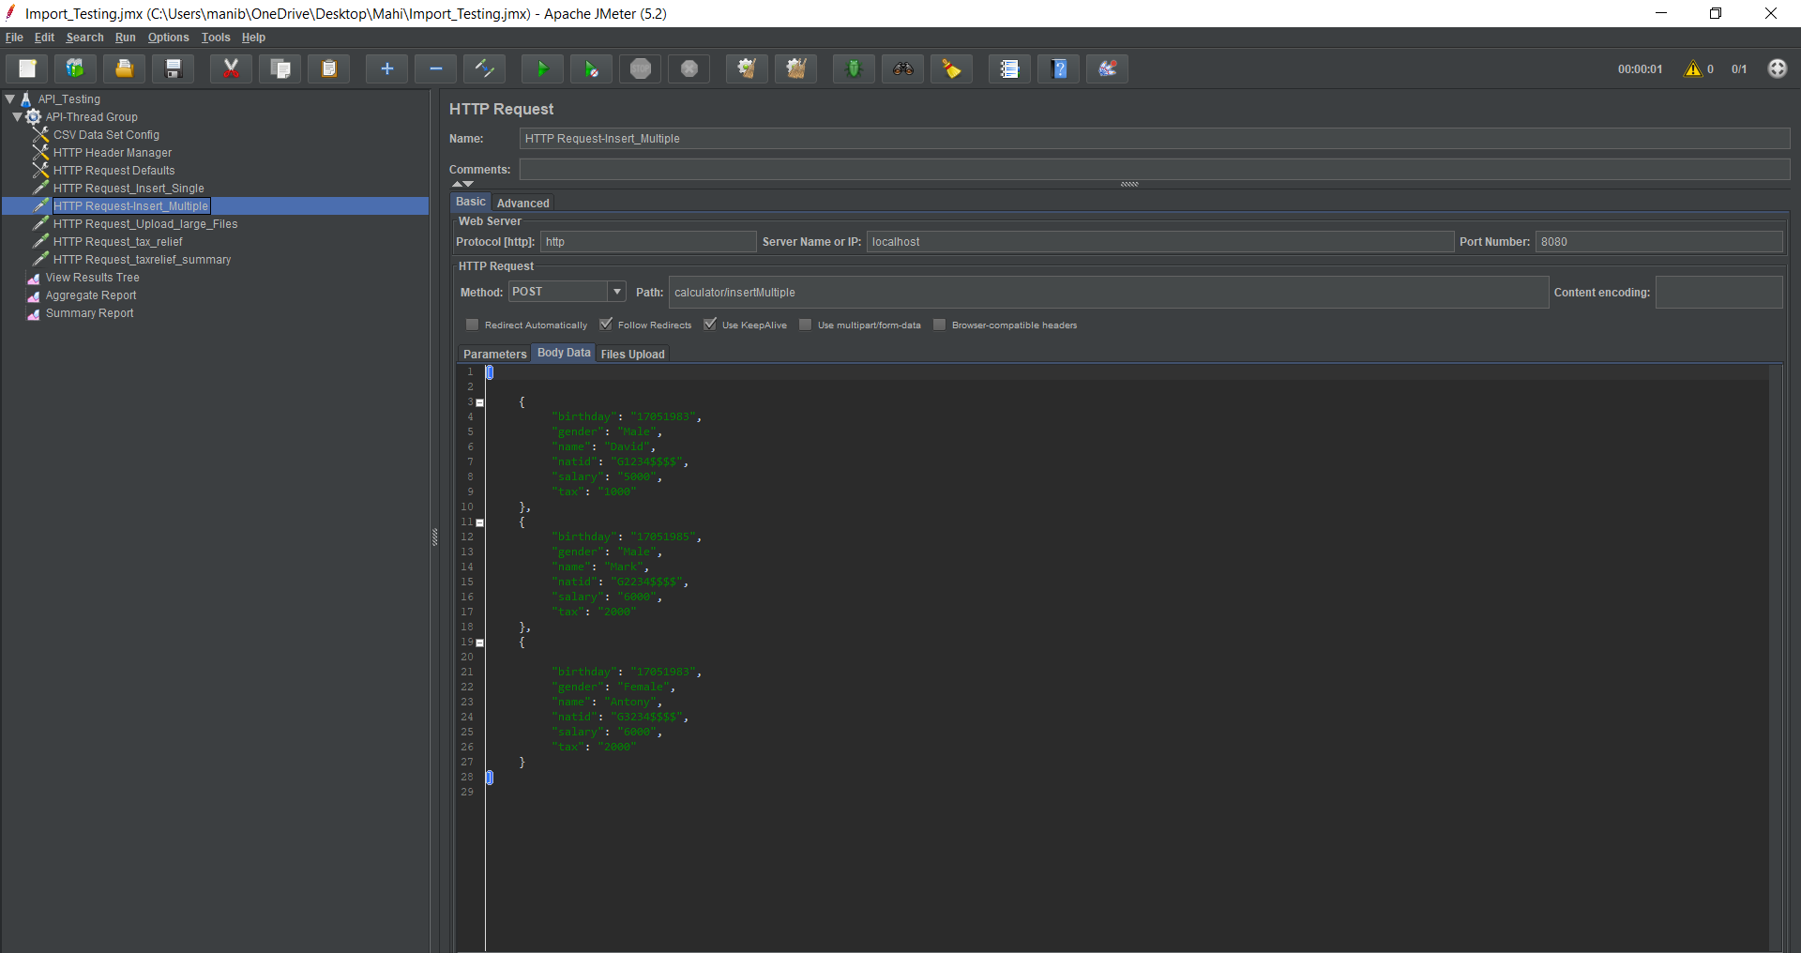

Step 11: Before “Upload larger Files”, set the configuration of the variables by using “CSV

Data Set Config”.

In CSV Data Set Config, Provide the “File name” and the “Variable Names”. In Variable names provide the field names with “Comma”.

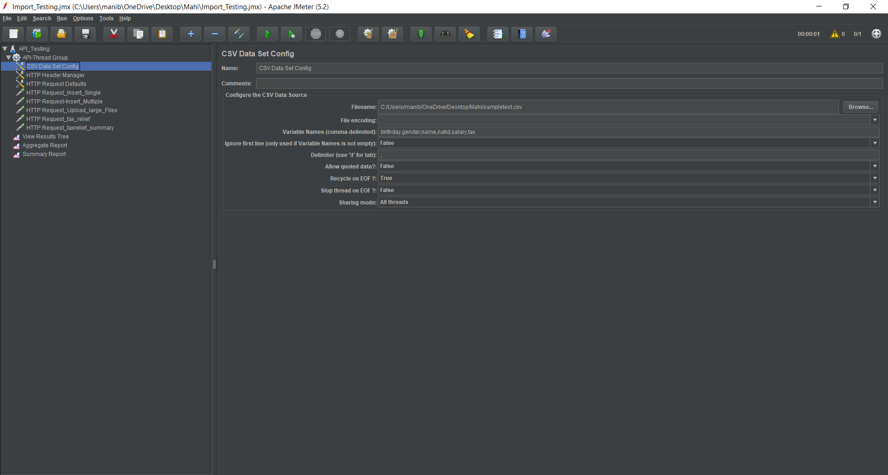

Step 12: For “Upload larger Files”,

1. In web Server, Set Protocol, Server Name/IP and Port Number.
2. In HTTP Request, Set Method as “POST” and Path.
3. In Body Data, provide json Request for upload lager files (CSV) by set parameter as Variable Names which is already provided in “CSV Data Set Config” and in the value part use the ${variable name} for passing the parameters .

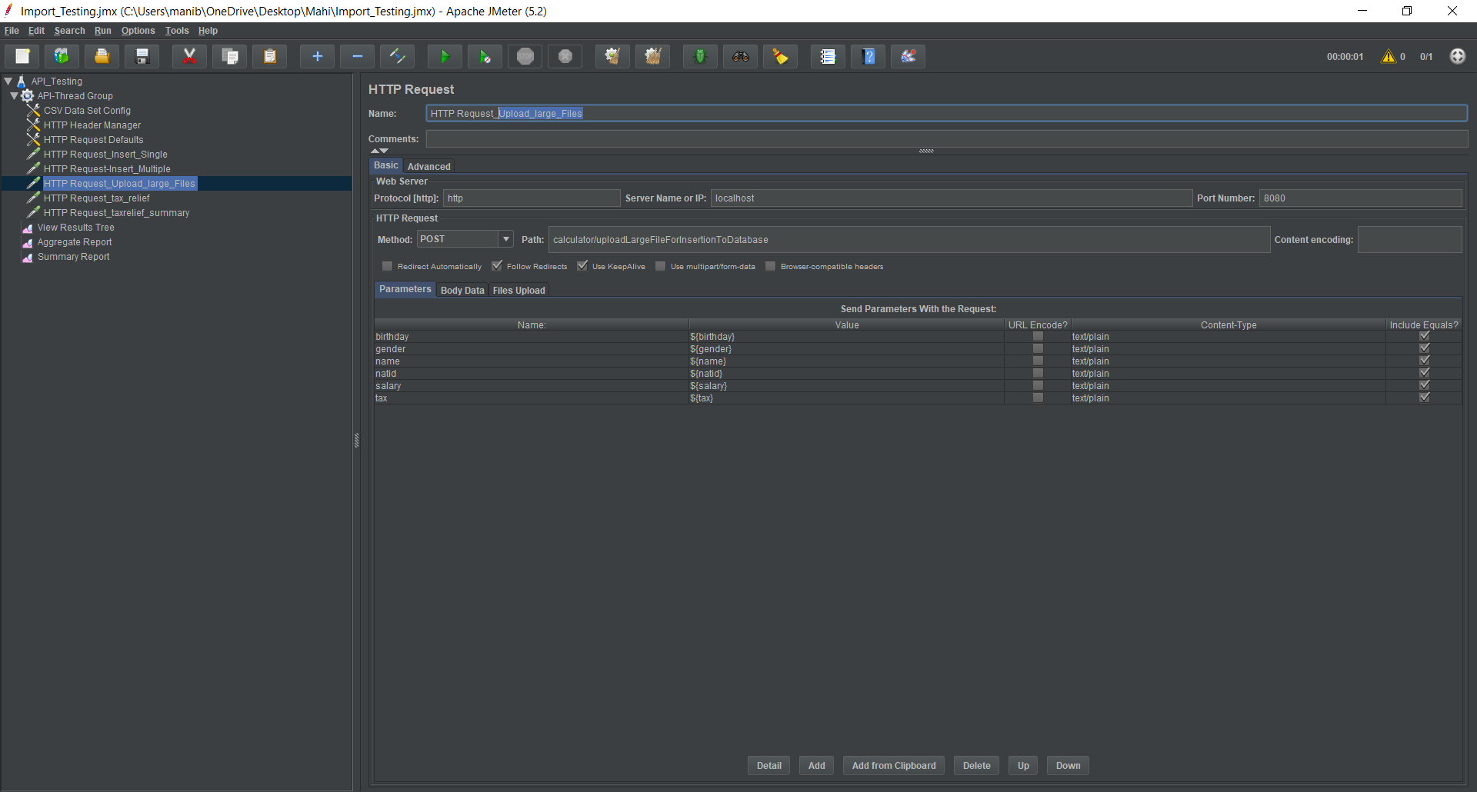

Step 13: Provide the “File Path” and “MME” Type in “File Upload”.

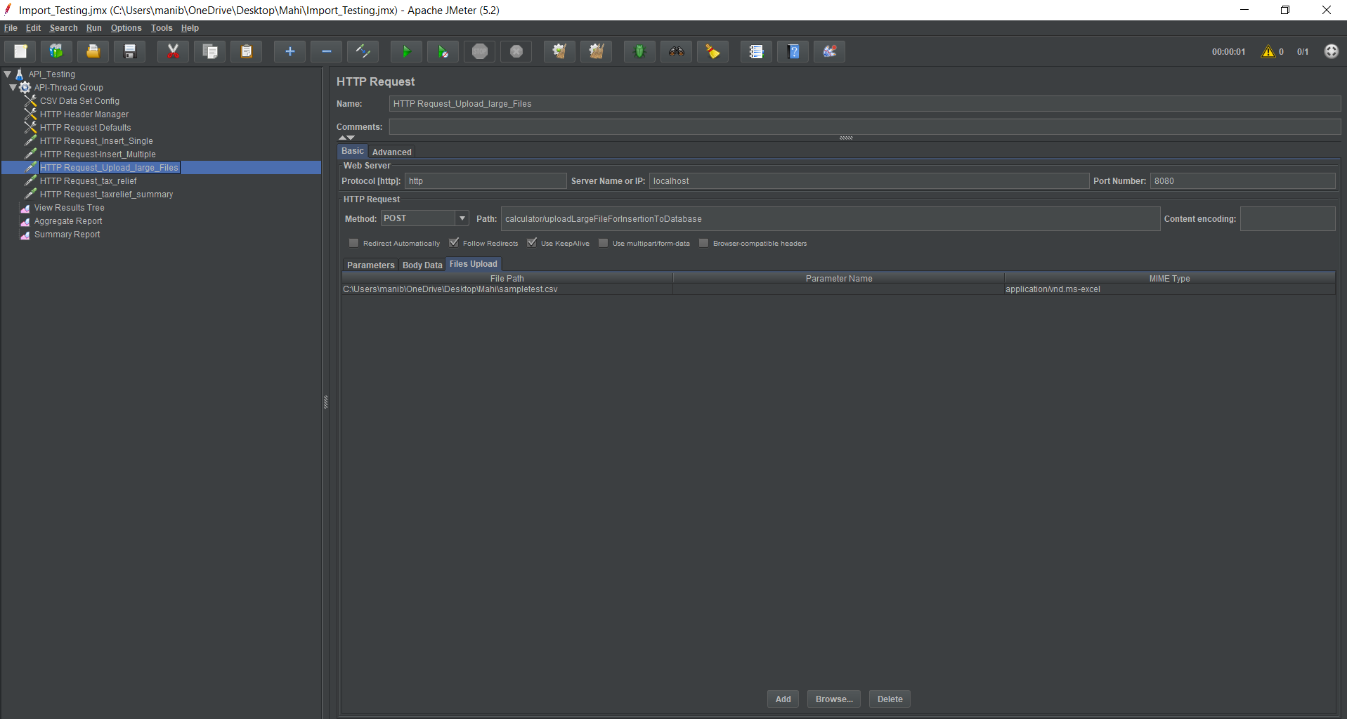

Step 14: For “Tax Relief”,

1. In web Server, Set Protocol, Server Name/IP and Port Number.
2. In HTTP Request, Set Method as “GET” and Path.
3. In Body Data, provide json Request for Tax Relief.

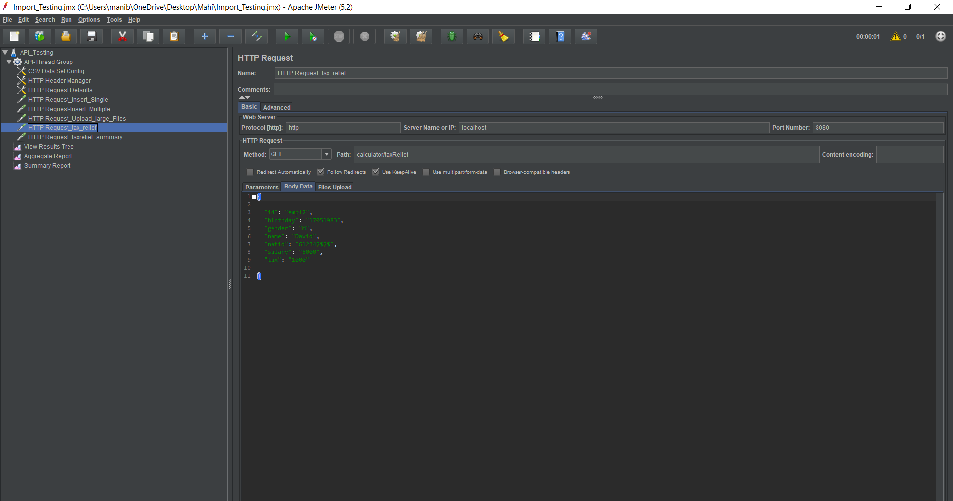

Step 15: For “Tax Relief Summary”,

1. In web Server, Set Protocol, Server Name/IP and Port Number.
2. In HTTP Request, Set Method as “GET” and Path.
3. In Body Data, provide json Request for Tax Relief Summary.

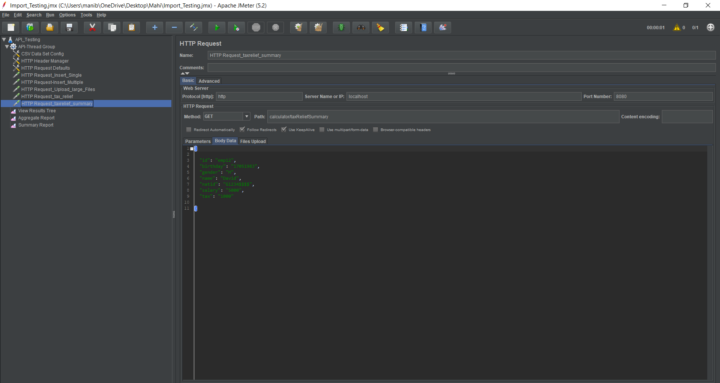

Step 16: For Results, “View Result Tree”, right click

on “Test Plan”, select “Add” option, in “Add” option select “Listener”, in “Listener”

select “View Result Tree”.

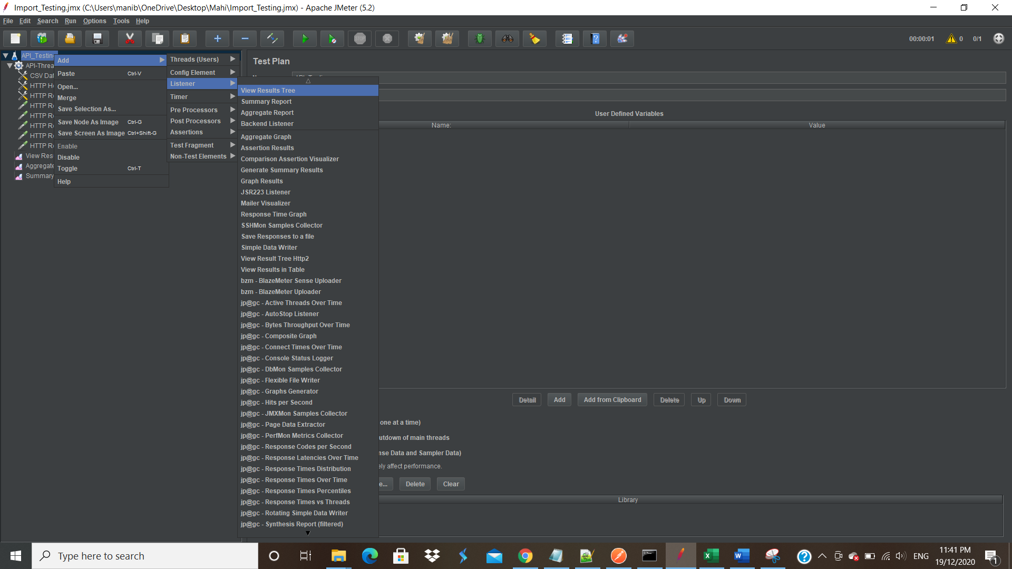

Step 17: The results will be shown by “View Result Tree”.

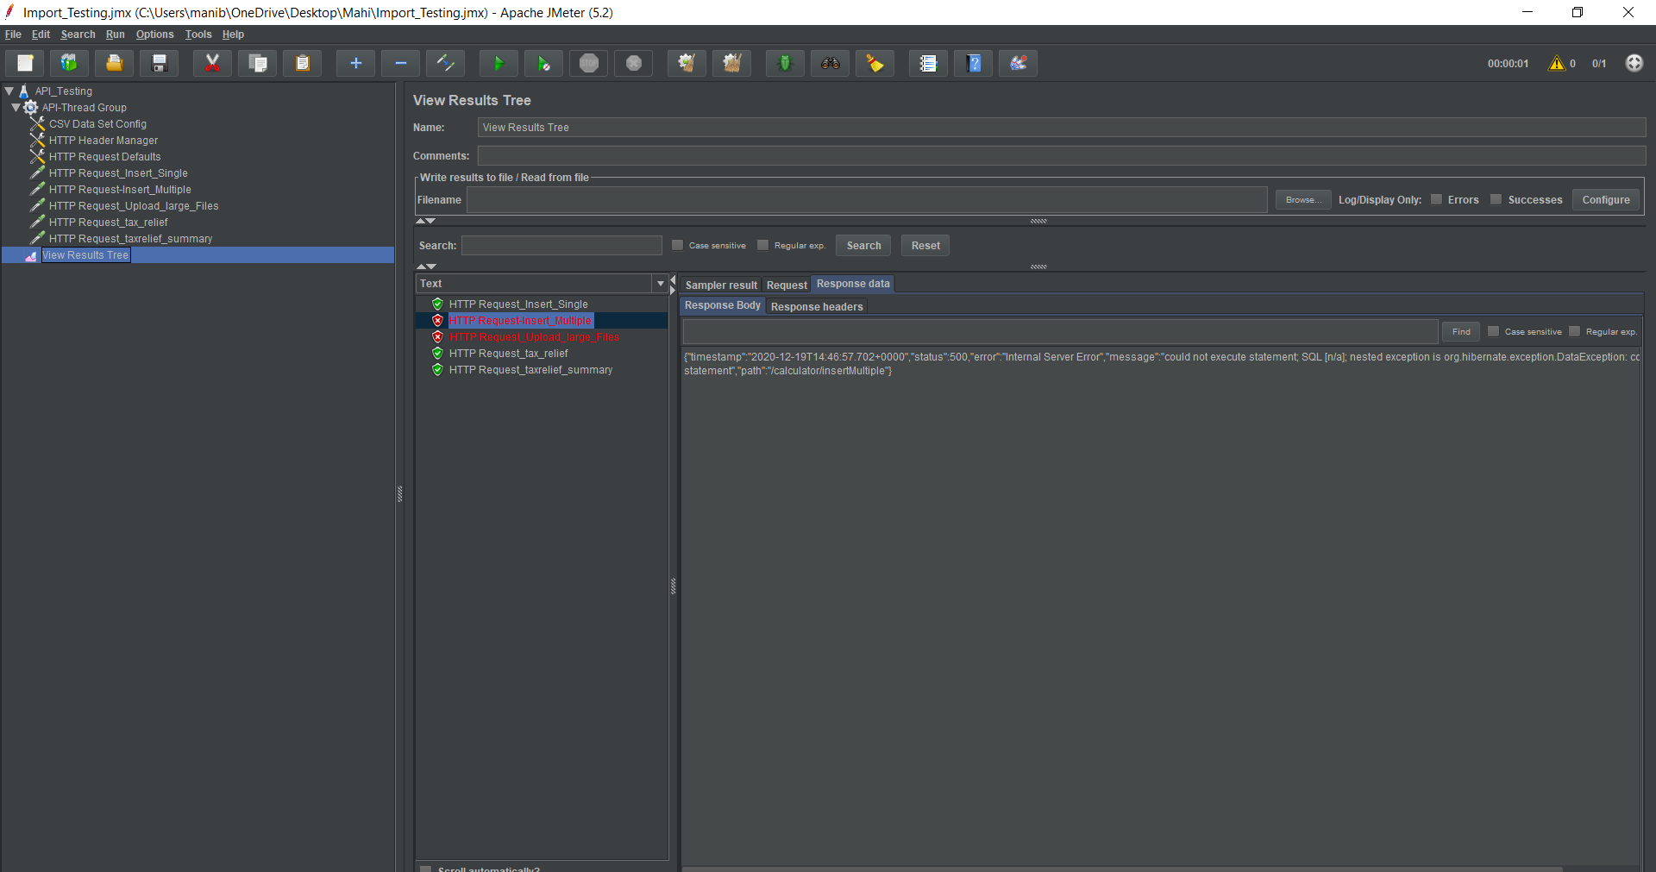

The result will be shown as Sampler Result, Request and Response Data.

**Results:**

For “Single Insert”,

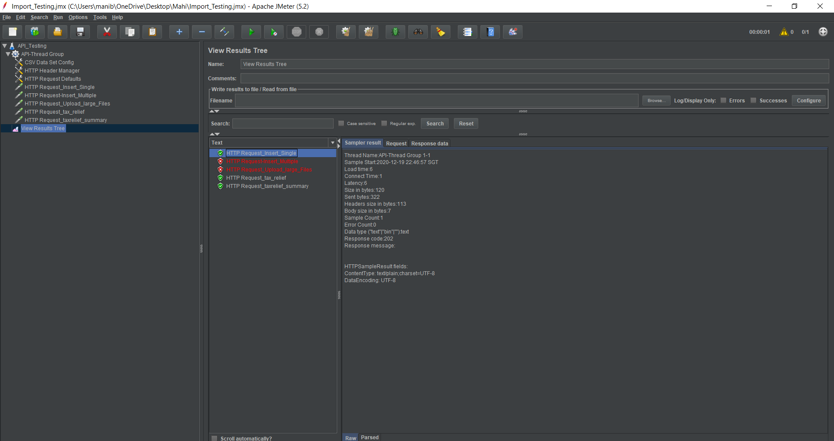

For “Multiple Insert”,

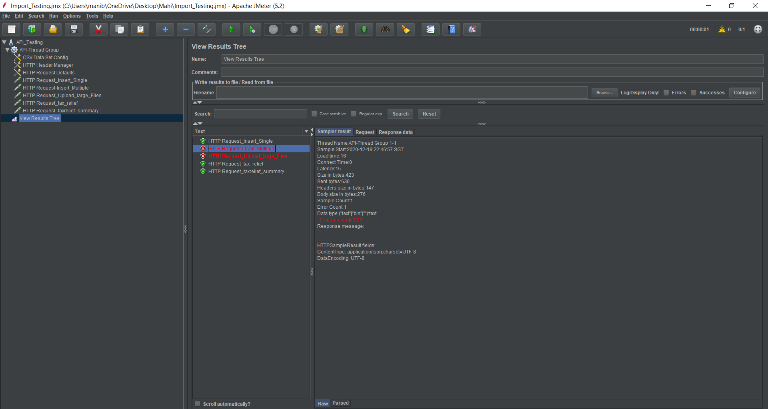

For “Upload Larger Files”,

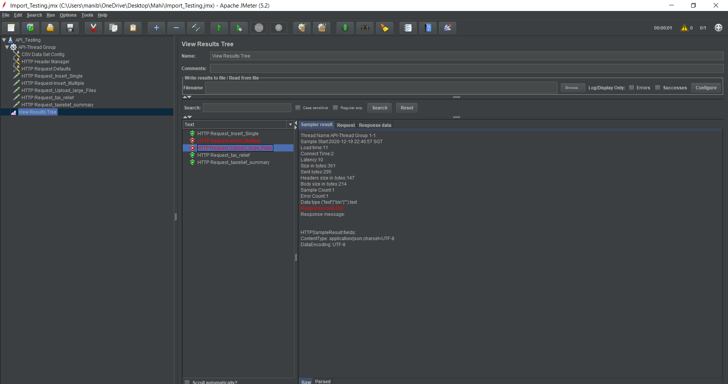

For “Tax Relief”,

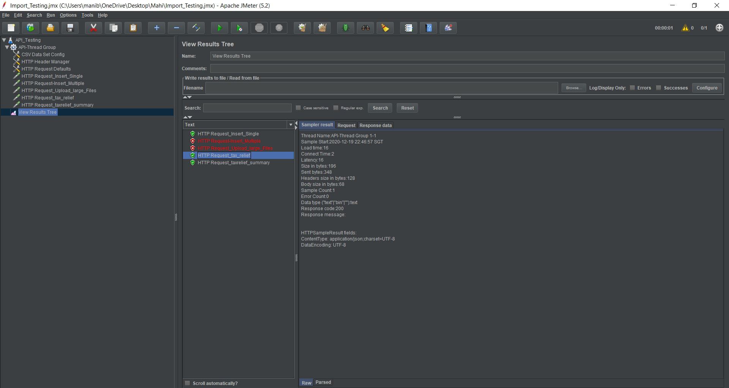

For “Tax Relief Summary”,

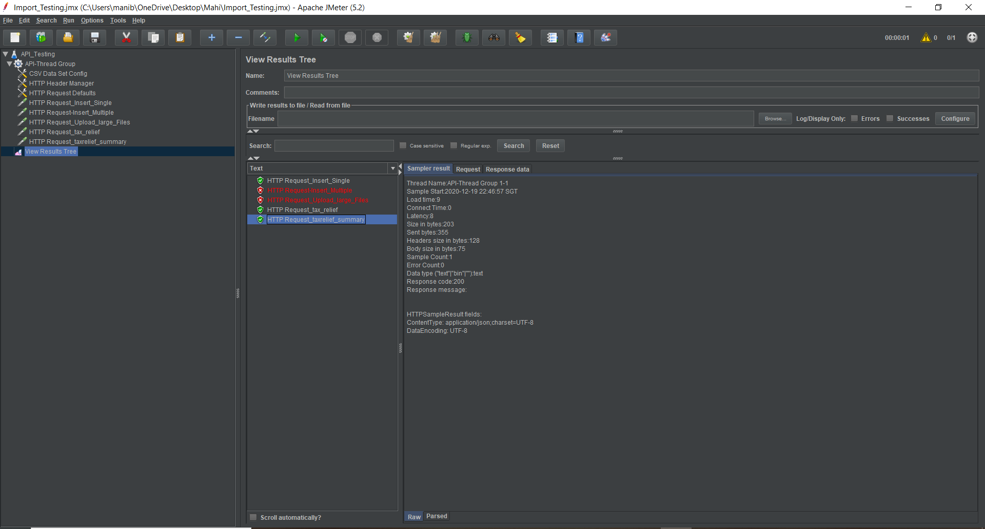

**PERFORMANCE TESTING**

Step 1: The test plan will show in JMETER home page.

Step 2: Change the test plan as appropriate project name and save the project.

Step 3: Right click on test plan choose “Add” option, in “Add” option choose Thread(users),

in “Thread” choose “Thread group”.



Step 4: Once thread group is created the below page is shown.



Set the HTTP Request Parameters from the above screenshots.

Step 5: In Thread group set the no.of users as per the expected load.

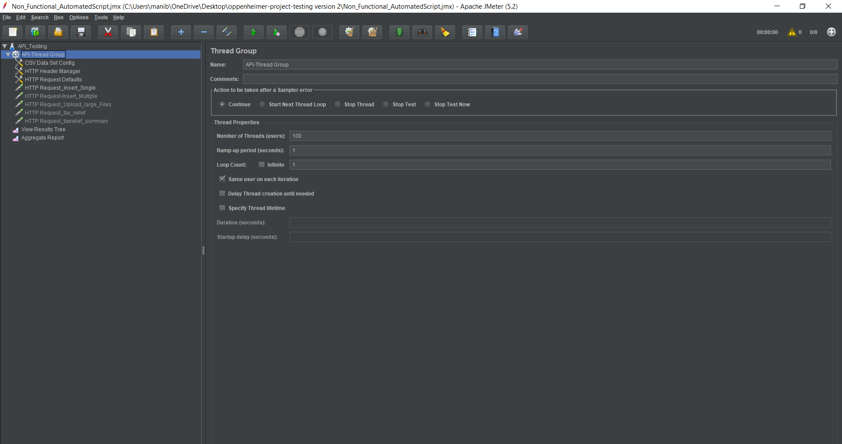

Step 6: Run the test plan. The results will be shown below.

1. Use “View Result Tree”, to verify the test results.

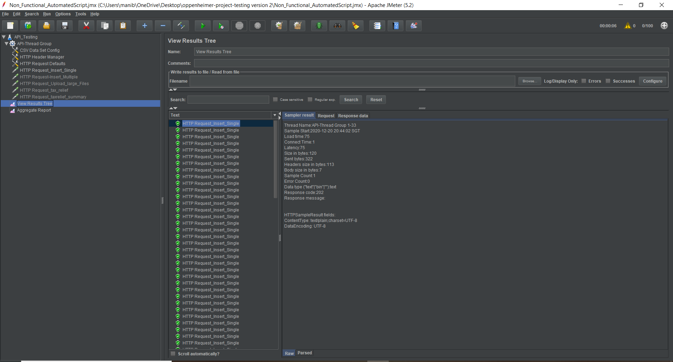

1. Use “Aggregate Report”, to verify the TPS, Error (if any) etc.

